ESCAP/WMO WRD/TC.41/6
Typhoon Committee
41st Session
Chiang Mai, Thailand

Review of the 2008 Typhoon Season
Annual publications
(Item 6)

FROM REPUBLIC OF KOREA

  - Overview of tropical cyclones which have affected/impacted Member’s area in 2008

- Meteorological Assessment (highlighting forecasting issues/impacts)
As of December 1, 21 typhoons formed in the Western North Pacific, and only one typhoon, ‘KALMAEGI(0)’the Republic of Korea this year. Typhoon(0807) formed on July 15 about 490 km off Northeast Manila, Philippines, showed track landing Taiwan and China, and then approached west part of Korea. The typhoon decayed to tropical depression (TD) at July 20, 2008, 1800 KST (Fig. 1). typhooninduced strong wind and rainfallwas observed at Kyecklyul-Bee-Do station (23.1m/s) and Changshu station (198.0mm), respectivly (Fig. 2).

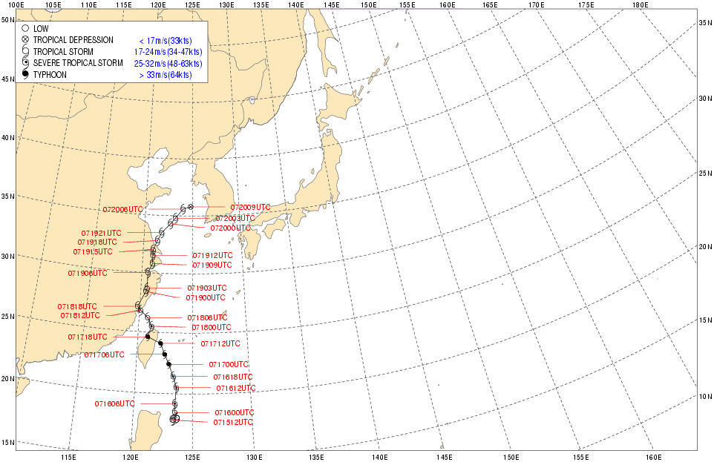
Fig. 1. Best track of typhoon KALMAEGI(0807) which affected Korea during 2008.

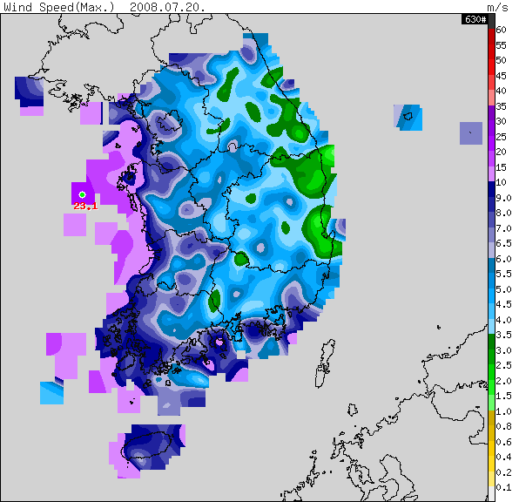 | 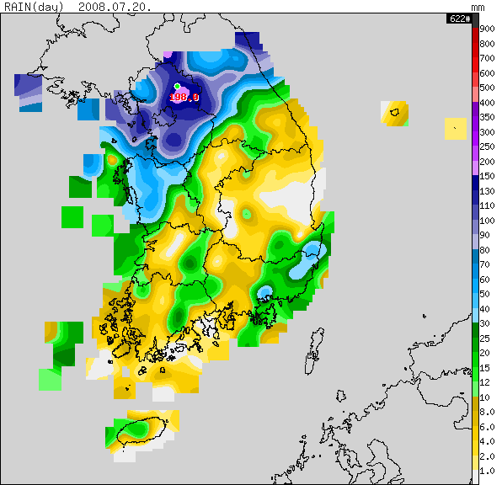
(a) | (b)
Fig. 2. Distribution of (a) maximum wind speed and (b) precipitation during the period that typhoon KALMAEGI approached to Korea on July 20, 2008.

- Hydrological Assessment (highlighting water-related issues/impact)

Typhoon 'KALMAEGI(0807)'
The 7th typhoon 'KALMAEGI' occurred on July 15, 2008 at 6 a.m., and approached to the Korean after passing through Taiwan and China. In Korea, a (severe) tropical storm warning was issued in the area of Seoul, Northern Gyeonggi Province and ern of Province from July 19, 2008. However, the typhoon did not bring significant damages on the peninsula, since it was while passing through Taiwan and China. Affecting the Korean till July 20, the typhoon 'KALMAEGI' vanished to a tropical depression with central pressure 1000 hpa approximately 170 km westbound from Gunsan.

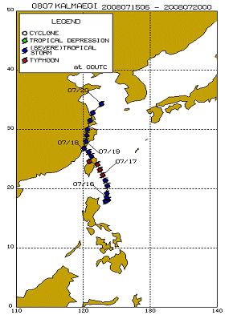
Fig. 3 Typhoon Tracks
(Sources: Typhoon Research Center, www.typhoon.or.kr)

Owing to the heavy rainfalls over 200 mm in the areas of Seoul, Northern Gyeonggi Province and Western Gangwon Province from July 19, the major dams of the Han River, Nakdong River and Geum River basins discharged respectively as shown in Table 1 below. The water levels were quite high enough for the dams to discharge water even after July 21, 2008,when the rainfall completely stopped. In particular, The Cheongphyung Dam discharged 17693/sec, Chunchun Dam discharged 742 m3/sec, Yuiam Dam discharged 778 m3/sec, and Paldang-Dam discharged 4,817 m3/sec.

Table 1. ischarge status of the major dams.
Basin | Dam Name | Discharging amount (m3/sec) | Time(KST)
Han River | Paldang | 2,890 | July 19,20:30
Han River | Singal Reservoir | 108 | July 19.08:00
Nakdong River | Namgang | 147 | July 18,18:00
South Han River | Gyeosan | 180 | July 19,11:00
Geum Gang | Yeadang Reservoir | 101 | July 19,10:00

Caused by the continuous rainfalls onJuly 20, the eight levees and two small facilities throughout the Chungchung Provinces in terms of public facilities; in the mean time, for private properties, 92 houses in total were flooded throughout Incheon, Gyeonggi Province, Northern/Southern Chungchung Provinces and 87.53 ha of farmlands in the areas of the Gyeonggi Province, Northern/Southern Chungchung Provinces were inundated. There were 268 refugees from the flooded 92 houses and the increased flows on rivers caused 4 civilian casualties.

- Socio-Economic Assessment (highlighting socio-economic and DPP issues/impacts)

Typhoon(0807) "KALMAEGI" was started from July 19, 2008 which m a flood related damages in some sub-basins of Republic of Korea. The accumulated rainfalls during three days from July 19 to July 21 are 208.5mm in the Inchun City, 214.0mm in the Suwon, 237.5mm in Seoul, 226.5mm in Yangpyeong, 214.0mm in Chungju, 161.5mm in Hongchun respectively. The maximum hour rainfall was 52.5 in Chungju, 49.5mm in Suwon, 37.0mm in Seoul, 30.0mm in Seosan respectively. Main damages are death of four persons, missing of one person, the suffers from flood of 271 persons in 93 houses, levee breakdown of 105m at four points, breakdown of one drainage channel, landslide of 0.6ha, and breakdown of one small bridge which damages are listed in Table .

Table . amages from the typhoon of "KALMAEGI"
Contents of Damages |  | Amount of Damages
Injures | Death | 1 Person
Injures | Missing | 4 Persons
Injures | Suffers | 271 Persons | 93 houses
Public Facility | River | 60m | 1
Public Facility | Stream | 65m | 2
Public Facility | River Bridge |  | 1
Private  Facility | Private House |  | 92 houses
Private  Facility | Irrigation Area | 87.58ha
Private  Facility | Ship |  | 1

- Regional Cooperation Assessment (highlighting regional cooperation successes and challenges)
- Nil.

